- 메인 포스터
2026 Fall Sports Day
“HI-Side Out” 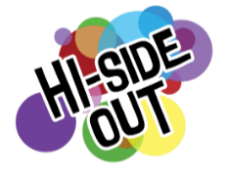

- 행사 소개
인사이드아웃 컨셉의 운동회.

🏆 Welcome to the 2026 HI-Club Sports Day, <HI-Side Out>! 🏆
Get ready to bring your emotions, energy, and team spirit to life at HI-Club’s exciting sports event! <HI-Side Out> is a special event where students come together to enjoy a fun-filled day of sports, teamwork, and friendly competition. Inspired by Inside Out, this year’s Sports Day is all about bringing different emotions, personalities, and people together to create unforgettable memories.
From exciting team games and sports activities to fun challenges, there will be plenty of opportunities to cheer for your team, meet new people, and show off your team spirit. Whether you’re competitive or just here to have fun, everyone is welcome to join in and enjoy the day!
For this Sports Day, each team will have its own matching team T-shirt! Wear your team T-shirt with pride, get ready to cheer on your teammates, and show everyone what your team is made of!
Come ready to play, cheer, connect, and show your team spirit at <HI-Side Out>!

Who: 교환 150명
Where: 율전 대운동장 (10:00 버스 출석 체크, 10:30 명륜 출발 버스 80명)
When: 9월 20일
Registration: 링크 트리 구글폼으로 선착순 접수 구글폼 오픈 일자 (8월 28일 16:00)
구글폼 링크
https://docs.google.com/forms/d/1tjOXz1q44hTyrGUP6kLhDaJfac8Ngbii9yVN3FTgCKU/edit

- 타임테이블

시간 | 구분 | 내용
13:00-13:30 | 개막 | 국민체조, 개회식 선서
13:30-14:50 | 1부 — 토너먼트형 게임 1 | 판 뒤집기
 | 1부 — 토너먼트형 게임 2 | 무궁화 꽃이 피었습니다
 | 1부 — 미니게임 | 제기차기, 비어퐁, 단체줄넘기
14:50-15:10 | 1부 — 메인게임 | 짝짓기 게임
15:10-15:45 | ─ 중간 휴식 ─ | 중간 점수 발표
15:50-17:10 | 2부 — 토너먼트형 게임 3 | 줄다리기
 | 2부 — 토너먼트형 게임 4 | <Protect the Sadness!> 피구
 | 2부 — 미니게임 | 페트병 세우기, 감정 표현 퀴즈, 병뚜껑 컬링
17:10-17:35 | 2부 — 메인게임 | 계주
17:35-18:00 | 시상 및 폐회 | 최종 점수 발표, 기념사진

- 점심식사 메뉴(예산안팀 메뉴 확정되는 대로)

For Vegan : 서브웨이 베지

For Non-Vegan : 돈치스팸 도시락

- 티셔츠 사이즈 안내

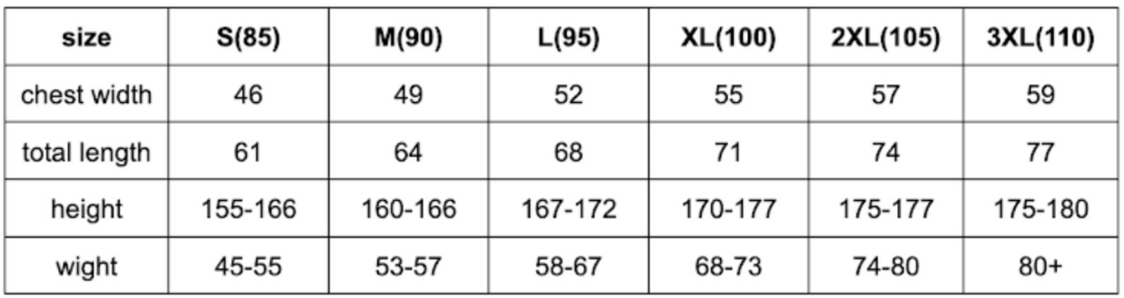
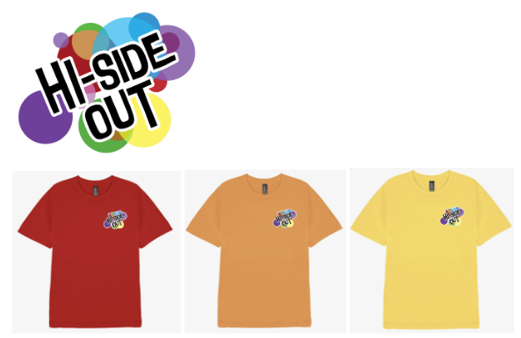
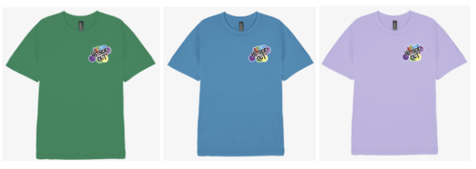
사진은 하나정도만 써도 괜찮을듯합니다)

- Important Notes
1. 🚫 NO ON-SITE Registration!!! 🚫
2. Please bring your own sunscreen and cap to avoid sunburns.☀️
3. If you have any physical disability that may affect your participation, please let us know in the form.
4. In case of bad weather, the event may be canceled or postponed. (We’ll notify you in advance.)
- ⚠️ Safety Rules ⚠️
1. Follow your team leader's and staff's instructions.
2. Avoid rough or dangerous play.
3. If you feel unwell, inform the staff immediately.
4. HI-Club will not be responsible for any lost or damaged items.

